INDUS UNIVERSITY



Bachelors Thesis

Under-Surface Object Detection Smart Robotic System Based On IOT (UODSRS)

THESIS SUBMITTED TOWARDS THE PARTIAL FULFILMENT OF THE OBLIGATION OF THE INDUS UNIVERSITY, FOR THE GRANT OF Bachelors of science in Computer Sciences

|  |
| --- |
| Abid Ali 799-2016  Sufyan Iqbal 594-2016  M. Mubashir Mughal 695-2016  Hyder Ali 824-2016  Computer Science  INDUS UNIVERSITY Pakistan  2019 |

# logo_png

# UNDERTAKING

We, Abid Ali, M.sufyan Iqbal, M.Mubashir Mughal and Hyder Ali hereby undertake that the project title ” Under Surface Object Detection Smart Robotic System Based On IOT” is a work done solely by ourselves and it has not been submitted anywhere else for any purpose to claim any credit. The affirmation project compromise of the following components is deliverables.

1. Complete Functioning Project
2. Complete Thesis Report (Hard Copy)
3. Project DVD (Source code, Thesis Report & Manual)

\_\_\_\_\_\_\_\_\_\_\_\_\_\_\_ \_\_\_\_\_\_\_\_\_\_\_\_\_\_\_ \_\_\_\_\_\_\_\_\_\_\_\_\_\_\_

Abid Ali M.Sufyan Iqbal M.Mubashir Mughal

\_\_\_\_\_\_\_\_\_\_\_\_\_\_\_

Hyder Ali

\_\_\_\_\_\_\_\_\_\_\_\_\_\_\_ \_\_\_\_\_\_\_\_\_\_\_\_\_\_\_ \_\_\_\_\_\_\_\_\_\_\_\_\_\_\_\_\_\_

DEAN Chairperson FYP Head Coordinator

Dr. Prof. Syed Zafar Nasir Dr. Zahoor Hussain Shah Miss Shagufta Aftab

# CERTIFICATE

This is to certify that the work present in this thesis entitled “under surface object detection smart robotic system based on IOT (UODSRS)” has been carried out by Abid Ali, Sufyan Iqbal, Mubashir Mughal and Hyder Ali under our supervision. The work is genuine, original and, in our opinion, suitable for submission to the Indus University for the grant of degree of BS in Computer Science

SUPERVISOR

\_\_\_\_\_\_\_\_\_\_\_\_\_\_\_\_\_\_\_\_\_\_\_\_\_\_\_\_\_\_\_\_\_\_\_\_\_\_\_\_\_\_\_

Dr. Zahoor Hussain Shah

Assistant Professor and Chairperson, Computing Department

FCIT

Indus University Karachi, Pakistan

CO-SUPERVISOR

\_\_\_\_\_\_\_\_\_\_\_\_\_\_\_\_\_\_\_\_\_\_\_\_\_\_\_\_\_\_\_\_\_\_\_\_\_\_\_\_\_\_\_

Dr. Sayed Zafar Nasir

Professor and DEAN

FEST

Indus University Karachi, Pakistan

# DEDICATION

We dedicated this project to God Almighty our creator, our strong pillar, our source of stimulation, perception, knowledge and sympathetic. He has been the source of our forte throughout this program. We also dedicate this project to our Parent’s and supervisors, who gave us soul and taught us that the best kind of knowledge and that even the largest task can be accomplished if it is done one phase at a time.

# ACKNOWLEDGEMENT

In the name of Allah who is the most substantial, compassionate and merciful.

We are grateful and would like to express our honest gratitude to our Supervisors. We have taken exertions in this project. However, it would not have been possible without the sympathetic support and help of many individuals, organization and our Supervisor. They gave us vital guidance, continuous encouragement and constant provision in making this research possible. We would like to spread our honest thanks to all of them.

We are highly obligated to Indus University for their facilities providing essential information concerning the project and also for their support in completing the project.

We would like to express our gratitude towards our parents & project supervisors of Indus University for their kind co-operation and encouragement which help us in completion of this project prototype.

Our thanks and appreciations also go to our colleague in developing the project and people who have willingly helped us out with their abilities.

# ABSTRACT

The aim of project is to design and develop an undersurface object detection smart robot based on NodeMCU. This will indicate the various obstacles under surface of earth. The systems smartly recognize the various routes and recommended the shortest path to search the object. In addition, the smart UODSRS disseminate the information via NodeMCU mechanism to upper surface component like (Mobile device, Application, web page & SMS application). The smart robots also search the alternative routes to reach the object in case of detection of various obstacles during the time movement.

This Proposed smart system has sufficient intelligence to cover the maximum area of provided space. It has sensors which are used to sense the obstacles coming in between the rout of robot. When the under surface objection smart robotic system based on IOT (UODSRS) detect obstacle which in its path, it sends alert to mobile application, web page & SMS application.

In addition, once the proposed system detects obstacles in its path, it relocates its direction to discover alternate path and disseminate that information to associated mobile application as well as web page.

# TABLE OF CONTENTS

[CERTIFICATE I](#_Toc535354875)

[DEDICATION II](#_Toc535354876)

[ACKNOWLEDGEMENTS III](#_Toc535354877)

[ABSTRACT IV](#_Toc535354878)

[TABLE OF CONTENTS V](#_Toc535354879)

[LIST OF TABLES VII](#_Toc535354880)

[LIST OF FIGURES VIII](#_Toc535354881)

[ABBREVIATIONS IX](#_Toc535354882)

[CHAPTER 1 1](#_Toc535354883)

[INTRODUCTION 1](#_Toc535354884)

[1.1 Motivation and Project Overview 1](#_Toc535354885)

[1.2 Background 1](#_Toc535354886)

[1.3 Problem Statement 2](#_Toc535354887)

[1.4 Aim and Objectives 2](#_Toc535354888)

[1.5 Scope of the Project 2](#_Toc535354889)

[1.6 Contributions of the thesis 3](#_Toc535354890)

[1.7 Structure of the thesis 3](#_Toc535354891)

[CHAPTER 2 4](#_Toc535354892)

[LITERATURE REVIEW/BACKGROUND 4](#_Toc535354893)

[2.1 Background 4](#_Toc535354894)

[2.1.1 Heading 4](#_Toc535354895)

[2.2 Related Work 5](#_Toc535354896)

[2.3 Comparative Study 6](#_Toc535354897)

[2.4 Summary 7](#_Toc535354898)

[CHAPTER 3 RESEARCH /SYSTEM Design 8](#_Toc535354899)

[3.1 RESEARCH /SYSTEM METHODOLOGY 8](#_Toc535354901)

[3.1.1 SOFTWARE REQUIREMENTS 8](#_Toc535354902)

[3.1.2 Hardware REQUIREMENTSs 9](#_Toc535354903)

[3.1.2 System Constraints 9](#_Toc535354904)

[3.1.2 External Interface Requirements 9](#_Toc535354905)

[3.2 Functional Requirements 9](#_Toc535354906)

[3.2.1 Use Cases 10](#_Toc535354907)

[3.2.2 Activity Diagram 10](#_Toc535354908)

[3.2.3 Sequence Diagram 10](#_Toc535354909)

[3.2.4 ER-Diagram 11](#_Toc535354910)

[3.3 Non-functional Requirements 11](#_Toc535354911)

[3.3.1 Performance Requirements 11](#_Toc535354912)

[3.3.2 Security Requirements 12](#_Toc535354913)

[3.4 Summary 12](#_Toc535354914)

[CHAPTER 4 19](#_Toc535354928)

[CONCLUSION AND FUTURE DIRECTIONS 19](#_Toc535354929)

[6.1 Conclusion 19](#_Toc535354930)

[6.2 Future Directions 20](#_Toc535354931)

[REFRENCES 21](#_Toc535354932)

# LIST OF TABLES

[Table ‎1: comparative study table 14](#_Toc469342563)

[Table 2: uc-1 table 25](#_Toc469342564)

[Table 3: uc-2 table 26](#_Toc469342563)

[Table 4: uc-3 table 26](#_Toc469342564)

[Table ‎5: uc-4 table 27](#_Toc469342563)

# LIST OF FIGURES

[Figure 1: Diagram of Coding 4](#_Toc469342569)

[Figure 2: Diagram of UODsrs 4](#_Toc469342569)

[Figure 3: Diagram of structure of uodsrs thesis 5](#_Toc469342570)

[Figure 4: Design of UODSRS 6](#_Toc469342569)

[Figure 5: Dataflow diagram of UODSRS 8](#_Toc469342570)

[Figure 6: dataflow diagram of obstscle avoiding robot 9](#_Toc469342569)

[Figure 7: Dataflow diagram of OBR(USA) 10](#_Toc469342570)

[Figure 8: Dataflow diagram of OBR(India) 11](#_Toc469342569)

[Figure 9: Block Diagram of VRRRS 12](#_Toc469342570)

[Figure 10: Dataflow diagram of Obstacle avoidance robot 13](#_Toc469342569)

[Figure 11: Dataflow diagram of Fuzzy logic Robot 14](#_Toc469342570)

[Figure 12: Diagram of system Methodology 17](#_Toc469342569)

[Figure 13: GUI of arduino Software 18](#_Toc469342570)

[Figure 14: gui of proteus 19](#_Toc469342569)

[Figure 15: Arduino micro-comtroller 20](#_Toc469342570)

[Figure 16: GSM communication module 21](#_Toc469342569)

[Figure 17: Ultrasonic sensor 21](#_Toc469342570)

[Figure 18: jumper wire 22](#_Toc469342569)

[Figure 19: switch 22](#_Toc469342570)

[Figure 20: thermal sensor 23](#_Toc469342569)

[Figure 21: Diagram of use case 26](#_Toc469342570)

[Figure 22: flow chart of uodsrs 30](#_Toc469342569)

[Figure 23: sequence diagram of uodsrs 31](#_Toc469342570)

[Figure 24:Simulation Result 3](#_Toc469342570)5

[Figure 25: Simulation Result](#_Toc469342569) 36

[Figure 26: Application and website for system UODSRS](#_Toc469342570) 42

[Figure 27: Application and website for system UOdsrs](#_Toc469342569) 44

[Figure 28: Application and website for system UODSRS](#_Toc469342570) 48

# ABBREVIATIONS

|  |  |
| --- | --- |
| UODSRS | Under surface object detection smart robotic system |
| OBR | Obstacle detection robot |
| VRRRTs | Voice Recognition Robot with Real Time Surveillance and Automation |
| IC | Integrated Circuit |
| IDE | integrated development environment |
|  |  |
| SMS | Short Message Service |
| IOT | Internet of things |
| LED | Light Emitting Diode |
| MCU | Node Micro-controller unit |
| IR | Infrared Sensor |
| PCB | Printed Circuit Board |
| VSM | Virtual System Modeling |
| FPGA | Field-Programmable Gate Array |
| PIR | Passive Infra-Red |
| IP | Internet Protocol |

# CHAPTER 1

# INTRODUCTION

An autonomous under surface objection detection smart robotic system based on IOT (UODSRS) is a smart robot that performs behaviors or tasks with a high degree of autonomy. Autonomous robotics is usually considered to be a subfield of artificial intelligence, robotics, and information engineering. Now a days autonomous robots are used everywhere in the world which are based on artificial intelligence. This inspired us to make a under surface object detection smart robotic system based on IOT (UODSRS) which has capability to detect obstacles and send alerts to disaster management group via android application, Web page and SMS application. After sending alert to disaster management group it changes it directions to discover the new available path.

## 1.1 Motivation and Project Overview

An autonomous robot (UODSRS) is a smart system that is capable of moving on different upper and under surface unstructured path. An autonomous robot is equipped with Artifical intelligence devices to sense environment, detect obstacles in its path and move around an environment to discover the possible path.When this proposed smart system (UODSRS) Once it detect the obstacles, the system sends alert to its associated mobile application or web page via IOT facility and change it directions to discover the new available path. The smart hardware has been controlled by Arduino mega 2560, micro-controller. The movements of under surface object detection smart robotic system based on IOT (UODSRS) has been control by per-code program to receive and disseminate the various alert. NodeMCU has been important into this project.

## 1.2 Background

The challenge of modern era, the smart systems is based on artificial intelligence, Internet of things and pervasive computing technologies used to mitigate and automate the mankind physical efforts. In this project a prototype smart robotic system has been design and developed to sense the obstacle under the surface of earth as well as upper surface of the earth and UODSRS is able to transmit the information on real-time basis via android app. In such situations, the environmental actions are partially controllable and observable by the smart robot system. Moreover, the existing robotic system do not directly controlled the human actions but capable to partial observation. In this project, a new paradigm will be introduced and incorporated the artificial intelligence and smart sensing technology which has been integrated to make the system autonomous. The autonomous system has capability to detect obstacles and send alerts via android app. This UODSRS is also detecting new available route within its way.

This UODSRS has sufficient intelligence to cover the maximum area of provided space. It has sensors which are used to sense the obstacles coming in the route of UODSRS. It will move in a particular direction and detect the obstacle which is in the route of UODSRS and send alerts via android app. The motors are going to give motion to the UODSRS. The construction of the UODSRS circuit is very complex and difficult to understand.

## 1.3 Problem Statement

In literature, many researchers proposed and design the smart system to detect the object on the upper surface of earth and these existing systems do not address the undersurface object detection and dose not evaluate the object (differentiate between living things and nonliving thing) and our proposed system UODSRS search the shortest route and selected the route to reached the target object and the proposed smart have not send various alerts on real time bases on users devices and Our proposed system UODSRS get data from sensors and manipulate that data and get real time decision to move in that environment.

## 1.4 Aim and Objectives

The aim of project is to design and develop an undersurface object detection smart system based on IOT. This has been indicated the various obstacles under surface of earth. The systems smartly recognize the various routes and recommended the shortest route to search the object.

In addition, the smart UODSRS disseminate the information via android app to upper surface components like (Mobile device).

The smart robots also search the alternative routes to reach the object in case of detection of various obstacles during the time movement.

The smart system can be used in disaster management area as well as in mining tunnels to save the human beings. Develop a real time communication mechanism between disaster area and user devices

## 1.5 Scope of the Project

The scope of project is to design and develop an undersurface object detection smart robot based on IOT. This will indicate the various obstacles under surface of earth (e.g. Coal mining). The systems smartly recognize the various routes and recommend the shortest route. In addition, the smart UODSRS disseminate the information via IOT mechanism to upper surface via android app. The smart robots (UODSRS) also search the alternative routes to reach the object in case of detection of various obstacles during the time movement.

## 1.6 Contributions of the thesis

All phases of smart system (UODSRS) are completed. In first iteration we design the hardware. In the second iteration we design circuit for Arduino Micro-controller, Ultrasonic Sensor, Servo motor and wheel after completion of first design of hardware then we developed the code for this circuit. This code working is to detect the obstacle and avoid the obstacle and change the available route with respect to environment. The circuit diagram and the code Snapshots are shown in Figure 1-2. The Figure is given below.

## 

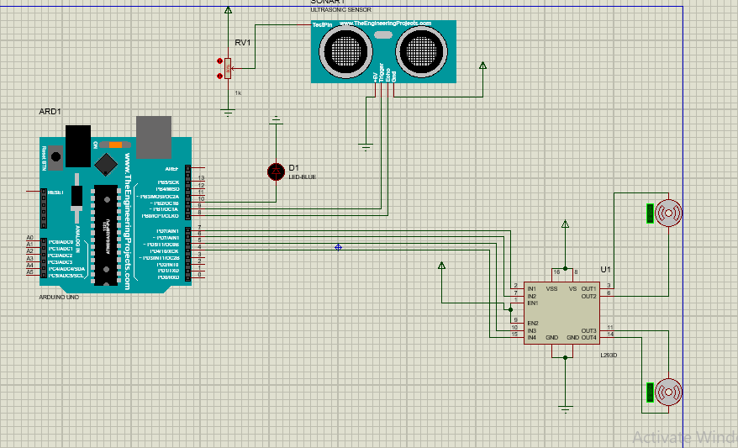Figure 1: Diagram of Coding

Figure 2: Circuit Diagram of Prototype

In above Figure 1 you see the code for the Arduino Mega 2560, Servo Motor and for ultrasonic sensor and in figure 2 you the connectivity or interfacing between the Arduino Mega 2560, Servo Motor and Ultrasonic sensor.

## 1.7 Structure of the thesis

The structure of UODSRS thesis is divided into six chapters. The chapters are Introduction of UODSRS, Literation review/Background, System Design, System implementation, Result & Discussion and Conclusion and future direction and the diagram of structure of UODSRS thesis is show in figure 3.

## Chapter 1

Introduction of UODSRS

Literation review/Background

## Chapter 2

## Chapter 3

System Design

System Implementation

## Chapter 4

Result & Discussion

Chapter 5

Conclusion and future direction

## Chapter 6

Figure 3: Diagram of Structure of UODSRS Thesis

# 

# CHAPTER 2

# LITERATURE REVIEW

The history of automation is characterized by periods of hasty revolution in popular methods. Either as a cause or, perhaps, an effect, such eras of change in automation techniques seem closely tied to world economics. Use of the industrial robot, which became recognizable as a unique device in the 1960s, along with computer-aided design (CAD) systems and computer-aided manufacturing (CAM) systems, characterizes the latest trends in the automation of the manufacturing process.

In this chapter we present the background of our project UODSRS, literature review of all research which is related to our project UODSRS and also compare the literature and our project.

## 2.1 Background:

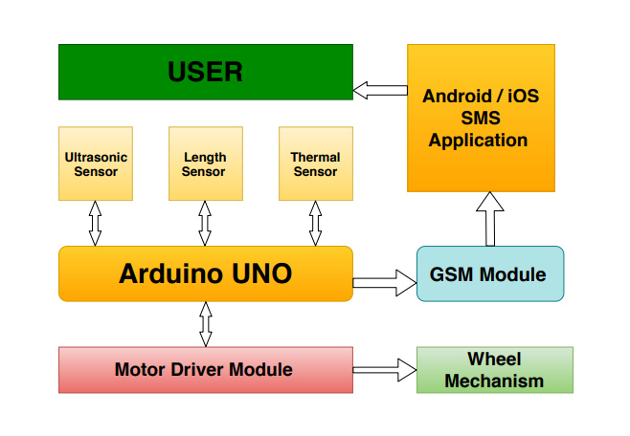UNDER SURFACE OBJECT DETECTION SMART ROBOTIC SYSTEM BASED ON IOT (UODSRS) with Using the Arduino Platform. Our goal of this project is to create a robot prototype that recognizes the obstacles and make real base communication to minimize the loss of life of those people who work in tunnels (e.g. Coal mining and mapped under surface places) with this robot prototype. It will be very useful where human penetration would not be feasible. The architecture of our UODSRS is shown in blow figure 4.

**NodeMCU**

Figure 4: Design of UODSRS

We used Arduino mega micro-controller, Sensor, DC Motor, Jumper Wires, Node MCU, Battery and Arduino IDE to construct our robot and for simulation we use Proteus IDE. The robot is autonomous and does real time communication with user about the environment around it.

### 2.1.2 working of UODSRS:

The smart robotic system (UODSRS) will design and develop to sense the obstacle under the surface of earth and as well as upper surface of the earth on the real-time basis. In such situations, the environmental actions are partially manageable and observable by the smart robot system. Furthermore, the existing robotic system does not directly controlled by the human actions but capable to partial observation. In this project, a new paradigm will be introduced and incorporated the AI and smart sensing techniques which will help to develop a full autonomous smart robotic system. The autonomous system would be capable to detect obstacles and send alert via android app (IOT). This robot will also detect new available route within its way. The flow diagram is shown in figure 5.

The smart proposed system UODSRS is used Ultrasonic sensor to sense the object undersurface of the earth and the upper surface of the earth and evaluate the object through PRI sensor and Send various alert to user via NodeMCU and the alert show in the mobile Application and as well as in Computer and we design the android application to controlled the UODSRS the feature of the application are Autonomous, Manual, Alert, Forward, Backward, Left, Right and stop.

When the users press the autonomous button the smart UODSRS move by itself and take real time decision and when any obstacles detect by the smart system UODSRS it generated the alert on application as well as on website to. We get alert on website through the IP address. When the users press the manual button in the application then the user have five options to control the smart system UODSRS the options are forward, backward, right, left and stop. When the smart system are in manual mode then it get command from the user to move forward, backward, left, right and stop and it does not send alert regarding any obstacles.

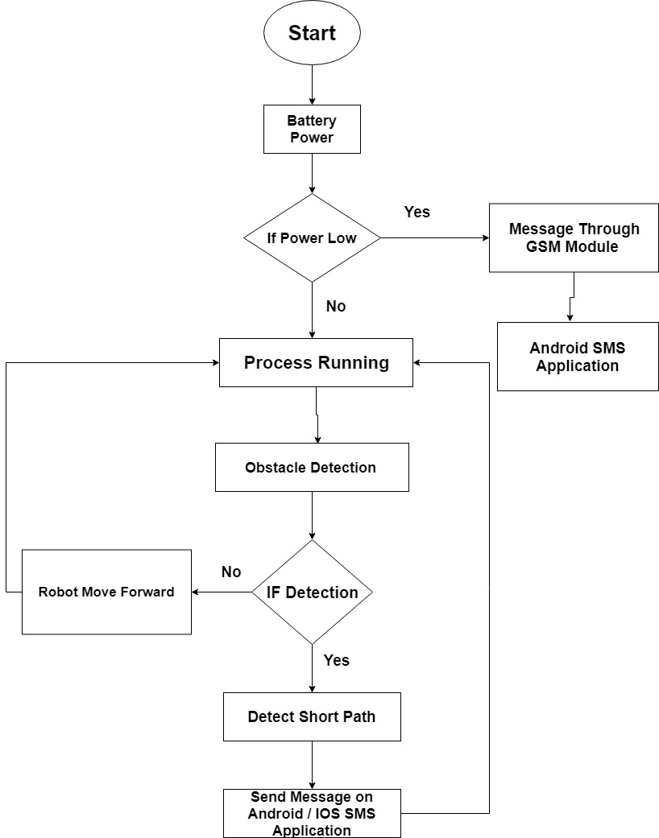

Figure 5: Data Flow of UODSRS

## 2.2 Literature Review

We evaluate almost seven different literature and research papers and there background or literature reviews are clarified below.

### 2.2.1 Obstacle Avoiding Robot:

Obstacle detection and avoidance can be considered as the vital issue in designing mobile robots. This technology provides sense which the robots can use to traverse in unfamiliar environments without damaging itself. In this paper, Obstacle Avoiding Robot is designed which can detect obstacles in its route and maneuver around them without making any collision. It is a robot vehicle that works on Arduino Microcontroller and employs three ultrasonic distance sensors to detect obstacles. The Arduino board was selected as the microcontroller platform and its software counterpart, Arduino Software, was used to carry out the programming. The integration of three ultrasonic distance sensors provides higher accuracy in detecting surrounding obstacles. Being a fully autonomous robot, it successfully maneuvered in unknown environments without any collision. The hardware used in this project is widely available and inexpensive which makes the robot easily replicable [1]. The flow diagram is shown in figure 6.

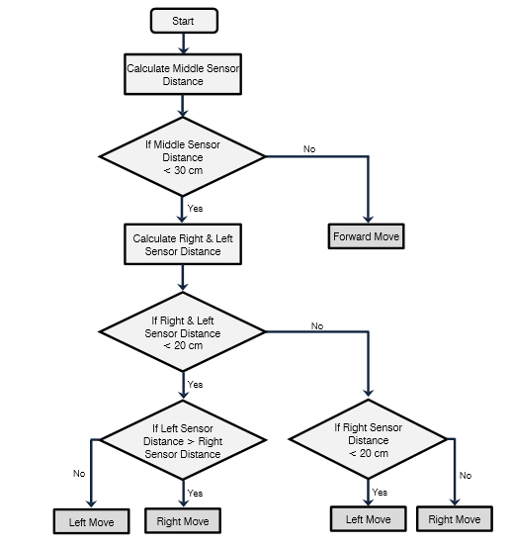

Figure 6: Obstacle avoiding Robot

### 2.2.2 OBR:

## Robot has sufficient intelligence to cover the maximum area of provided space. It has an infrared sensor which is used to sense the obstacles coming in between the route of Robot. It will move in a particular direction and avoid the obstacle which is coming in its route. Autonomous Intelligent Robots are robots that can perform desired tasks in unstructured environments without continuous human guidance. [2]

It is the part of Automation; Robot has sufficient intelligence to cover the maximum area. This robot uses infrared sensor to detect the obstacle in between the route and then avoid them to complete its objective. The IR transmitter continuously generate an Infrared signal of 38KHz,when an obstacle comes in the route the infrared signal reflected back from the object and is received by the IR sensor TSOP1738 and then generate a positive high signal with the help of the receiver circuit that is there is an obstacle in the route. In such a way the robot is able to detect obstacles of provided space and able to avoid obstacles coming in between the route of robot with the help microcontroller board and complete its journey [2]. The flow diagram is shown in figure 7.

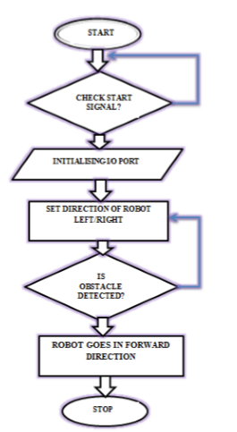

Figure 7: Dataflow Diagram of OBR

### 2.2.3 Obstacle avoiding Robot:

An obstacle avoiding robot is an intelligent device, which can automatically sense and overcome obstacles on its route. Obstacle Avoidance is a robotic discipline with the objective of moving vehicles on the basis of the sensorial information. The use of these methods front to classic methods (route planning) is a natural alternative when the scenario is dynamic with an unpredictable behavior. In these cases, the surroundings do not remain invariable, and thus the sensory information is used to detect the changes consequently adapting moving. It will automatically scan the surrounding for further route.

This project proposes robotic vehicle that has an intelligence built in it such that it directs itself whenever an obstacle comes in its route. So to protect the robot from any physical damages. This can be design to build an obstacle avoidance robotic vehicle using ultrasonic sensors for its movement. The flow Diagram is shown in figure 8.

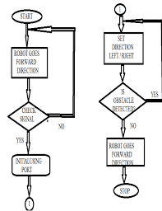

Figure 8: Data Flow Diagram of Obstacle avoiding Robot

### 2.2.4 VRRRS:

Voice recognition is the technology in which a single voice command can perform a real world operation. The concept of voice recognition is deals with the conversion of input voice signal into its corresponding text through an android application and transmission of this text message through Bluetooth connectivity as a means of communication platform. In the other hand a controller circuit can receive a text signal through Bluetooth module and as per the coding mechanism it performs real world operation. This paper also enhances the concept of real-time surveillance and automation where an obstacle detection and avoidance mechanism along with lighting and horn operates through predefined voice command. Our purposed technique will act as a helping hand for disable people and also useful in industrial automation robot to perform certain particular task. The block diagram is shown in figure 9.

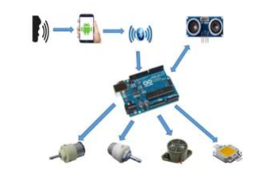

Figure 9: Block Diagram of VRRRS

### 2.2.5 Path tracking Robot:

The sentry wizard is a motion sensing patrol robot with enhanced vision processing abilities.it will roam and area and rely on a high frame rate CMOS camera and an FRGA to identify moving objects, track them. And predict their future route. From there the robot will aim a target marking turret at the target and fire at it while continuing to track.

The robot will has a short cylindrical body and two wheels for easy turning a rotating turret with automatic firing for target marking an Arduino to interface with peripherals, and a vision tracking system handled by a priories Merlin 2 with cyclone IIII FPGA.

### 2.2.6 Obstacle avoidance Robot:

Robotic vehicle that has an intelligence built in it such that it directs itself whenever an obstacle comes in its route. This robotic vehicle is built, using a micro-controller of AT mega 8 family. An ultrasonic sensor is used to detect any obstacle ahead of it and sends a command to the microcontroller. Depending on the input signal received, the micro-controller redirects the robot to move in an alternate direction by actuating the motors which are interfaced to it through a motor driver.

Obstacle avoidance is a primary requirement of any autonomous mobile robot. Obstacle avoidance Robot controlling through remote. Here driver is present, who can see the obstacle and navigate robot accordingly. The flow diagram is shown in figure 10

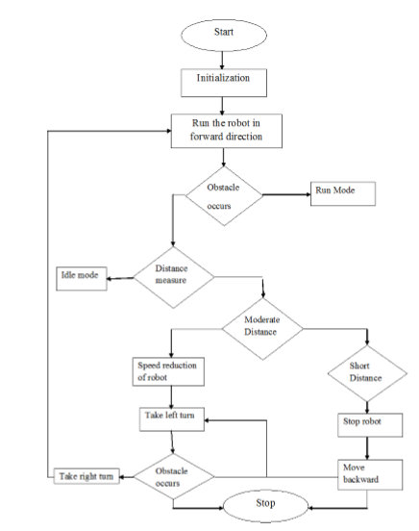

Figure 10: Dataflow Diagram of Obstacle avoidance Robot

### 2.2.7 Fuzzy Logic Robot:

Navigation system for an autonomous robot is an area that is undergoing constant development. This paper describes an autonomous robot that is capable of navigating in a real time environment. This can be achieved by obtaining the information about robot’s environment by using sensors and process it. For implementation of obstacle avoidance, Fuzzy Logic approach is used and is implemented using Arduino-Uno board on mobile robot platform with three sets of ultrasonic sensors mounted on it. The Fuzzy Logic approach allows us to use the ultrasonic or infrared sensors that allow fast and cost effective distance measurements with varying uncertainty. The functionality diagram is shown in figure 11.

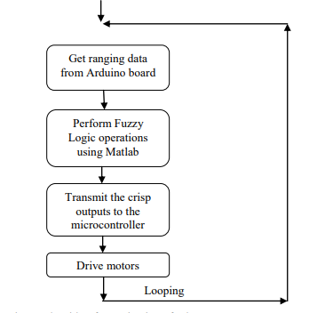

Figure 11: Dataflow Diagram of Fuzzy Logic Robot

## 2.3 Comparative Study

There are so many relevant work has been done with respect to our project UODSRS but there are so tymany new thing which we introduced in our project UODSRS. The table shows the comparison between our project and the projects we reviewed.

|  |  |  |  |  |  |  |
| --- | --- | --- | --- | --- | --- | --- |
|  | UODSRS | Obstacle Avoiding Robot  (USA) | Obstacle Avoiding Robot  (Indian) | Obstacle Avoiding Robot using Arduino | VRRRTS | Obstacle Avoidance Robot |
| Autonomous | ✓ | ✓ | ✓ | ✓ | X | ✓ |
| Route Read | ✓ | ✓ | ✓ | ✓ | ✓ | ✓ |
| Object Detection | ✓ | ✓ | ✓ | ✓ | ✓ | ✓ |
| Evaluate Object | ✓ | X | X | X | X | X |
| Length Measure | ✓ | ✓ | X | ✓ | X | ✓ |
| Send Alert | ✓ | X | X | X | X | X |

Table 1: Comparative study table

## 2.4 Summary

In this paper an Obstacle Avoiding Robot is designed which can detect obstacles in its route and maneuver around them without making any collision.

In this paper the robot will move in a particular direction and detect the obstacle and evaluate obstacle and send alert to user.

In this paper a robotic vehicle that has an intelligence built in it such that it directs itself whenever an obstacle comes in its route.

This paper also enhances the concept of real-time surveillance, Automation and real-time basis communication where an obstacle detects.

In this paper the robot will aim a target marking turret at the target and fire at it while continuing to track.

In this paper the robot will directs itself whenever an obstacle comes in its route.

This paper describes an autonomous robot that is capable of navigating in a real time environment.

As you see above we described so many paper which are similar to our proposed system UODSRS but in our system UODSRS has some different functionalities than above proposed system which are already available on websites. The functionalities of our proposed system are following below.

1. Autonomous
2. Manual controlled by application
3. Object detection
4. Object evaluation (different between living thing and non-living thing)
5. Real-time communication
6. Real-time decision

# CHAPTER 3

# System Design

In this chapter we provide motivation and contributions of this thesis and at the end of the chapter, we present structure of the rest of the thesis.

## 3.1 System Methodology

In order to develop a UODSRS prototype module we use an agile system development methodology because the developer complete project in iteration through this methodology developer easily find the error and if developer need to add something new in project then he easily add that feature in project. The phases of our system methodology are shown in figure 12.

Agile System

Development Methodology

Figure 12: Diagram of System Methodology

As you see in figure 12 above us in agile mythology have four phases are in iteration and the phases are planning, Designing, Coding/Implementation and testing. In planning phase we decide that what we need in this iteration and make complete that all need which we need in that iteration and in designing phase we design the structure before coding and in implementation we create a code and we test that code through unit testing and completion of these four we get one product.

### 3.1.1 Software Requirements

To develop UODSRS prototype we use Arduino Software, MIT app inventor 2 and Proteus IDE and Arduino software is a platform which is used to make program for Arduino board according to user requirements and Proteus IDE is used to simulate electronics devices so we choose this IDE to simulate our robot and check the result of program and check the device are attach properly with Each other’s and App Inventor lets you develop applications for Android phones using a web browser and either a connected phone or emulator. The App Inventor servers store your work and help you keep track of your projects. You build apps by working with: The App Inventor Designer, where you select the components for your app. The more detail about software is given below.

### 3.1.1.1 Arduino Software:

Arduino software is a platform which is used to make program for Arduino board according to user requirements. The Arduino IDE uses a simplified version of C++ and it GUI is show in Figure 13.

Arduino was born at the Vera Interaction Design Institute as an easy tool for fast prototyping, aimed at students without a background in electronics and programming. As soon as it reached a wider community, the Arduino board started changing to adapt to new needs and challenges, differentiating its offer from simple 8-bit boards to products for IoT applications, wearable, 3D printing, and embedded environments. All Arduino boards are completely open-source, empowering users to build them independently and eventually adapt them to their particular needs. The [software](https://www.arduino.cc/en/Main/Software), too, is open-source, and it is growing through the contributions of users worldwide.

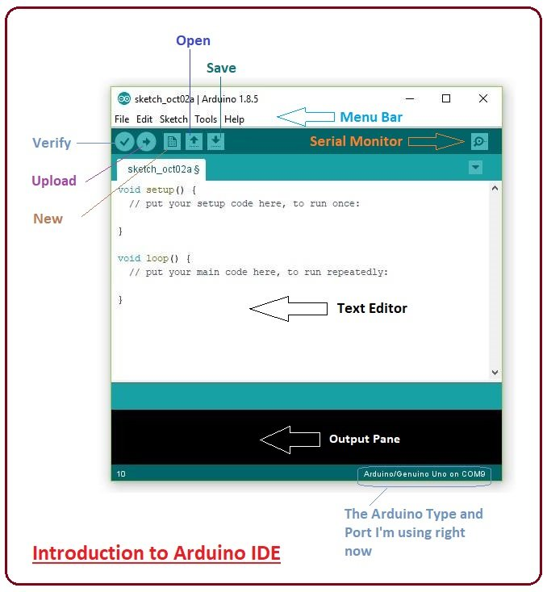

Figure 13: GUI of Arduino Software

### 3.1.1.2 Proteus IDE:

It is software which is used to simulate electronics devices so we choose this IDE to simulate our robot and check the result of program and check the device are attach properly with Each other’s and the GUI view of Proteus in shown in figure 14.

The Proteus Design Suite is a proprietary software tool suite used primarily for [electronic design automation](https://en.wikipedia.org/wiki/Electronic_design_automation). The software is used mainly by electronic [design engineers](https://en.wikipedia.org/wiki/Design_engineer) and technicians to create [schematics](https://en.wikipedia.org/wiki/Schematic) and electronic prints for manufacturing [printed circuit boards](https://en.wikipedia.org/wiki/Printed_circuit_board).

Proteus is a simulation and design software tool from Lab center Electronics for electrical and Electronics circuit design. This Proteus software suite containing schematic and simulation with PCB designing.  
**ISIS** is the software used to draw schematic and simulate the circuits in real time.  
ARES is used for PCB designing. It has the feature of viewing output in 3D view of the designed PCB along with components.  
The Proteus 8 Design Suite software can interacting the embedded projects with LED, LCD displays, and switches also interface with software sensors. In need of practical implementation of the projects circuits, we have to test with our C program and how it works or not. Proteus 8 Design suite is a one of the Virtual system Modeling (VSM) with spice circuit simulation, with animated electronic components.

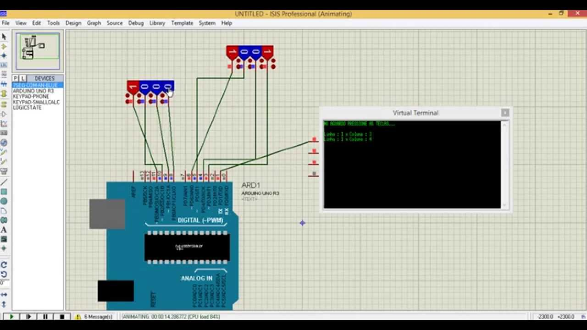

Figure 14: GUI of Proteus IDE

### MIT app inventor:

App Inventor lets you develop applications for Android phones using a web browser and either a connected phone or emulator. The App Inventor servers store your work and help you keep track of your projects. You build apps by working with: The App Inventor Designer, where you select the components for your app.

Software Genre: Integrated development environment

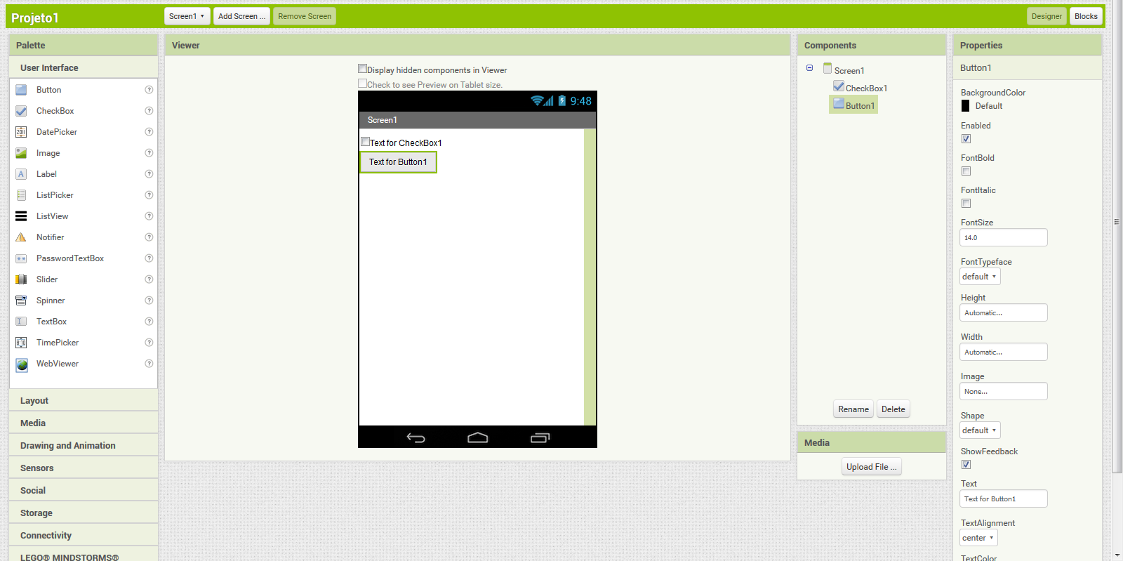

### 3.1.2 Hardware Requirement

There are following hardware is use to constructed UODSRS:

1. Arduino Micro-Controller
2. Node MCU
3. Ultrasonic Sensor
4. Thermal Sensor
5. Length Sensor
6. Jumper Wires

#### 3.1.2.1 Arduino Micro-Controller (MEGA):

Arduino Micro-controller is a brain of our robot because it control all component which attach with it through IC chip in which we installed the program. It receives data with the help of signals from component and sends data to component with the help of electronic signals. We install our program in Arduino Micro-Controller through USB port. There are 4 input pin and 4 output pins in Micro-controller. We attach component e.g. (Sensor and GSM Communication Module) through these port and it show in figure 15.

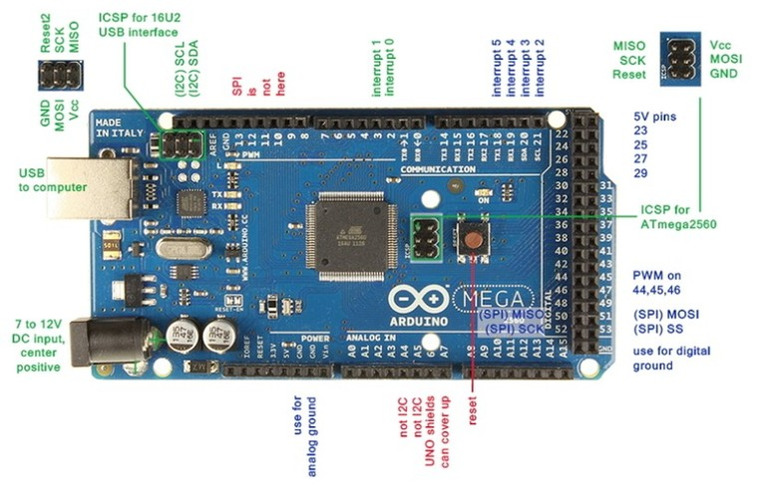

Figure 15: Arduino Micro-Controller (MEGA)

### 3.1.2.2 NODE MCU:

NodeMCU is an open source IOT based firmware developed for ESP8266 WIFI chip. By exploring functionality with ESP8266 chip, NodeMCU firmware comes with ESP8266 Development board/kit i.e. NodeMCU Development board. Node MCU is pictured in figure 16.

ESP8266 is a low-cost, Wi-Fi Module chip that can be configured to connect to the Internet for Internet of Things (IoT) and similar Technology Projects. Basically, your normal Electrical and Mechanical equipment’s cannot connect to the Internet on their own.

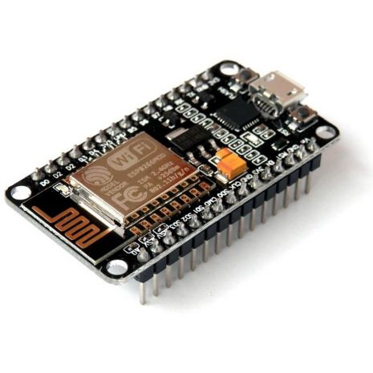

Figure 16: Node MCU

### 3.1.2.3 Ultrasonic Sensor:

Ultrasonic sensor is a device which produced sound waves. We use this device is to detect the object and we use this sensor is also for measure the distance between the robot and object. There are four pin in Ultrasonic Sensor GND, Trigged, Echo and VCC through these pin ultrasonic sensor connect with Arduino and it show in figure 17.

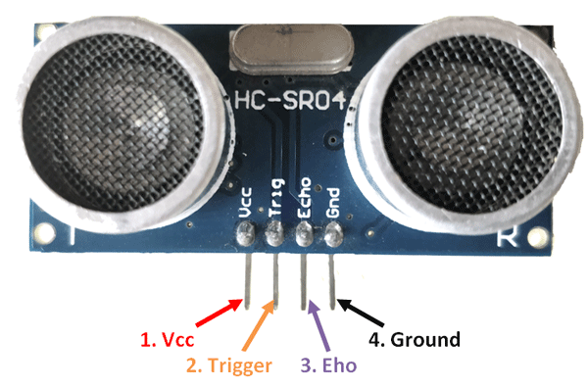

Figure 17: Ultrasonic Sensor

#### 3.1.2.4 JUMPER wires:

The tiny wires which is used to make any architype. We use jumper wires to make provide connectivity between Arduino and Other component e.g. (Node MCU and ultrasonic sensor etc.) and it shown in figure 18.

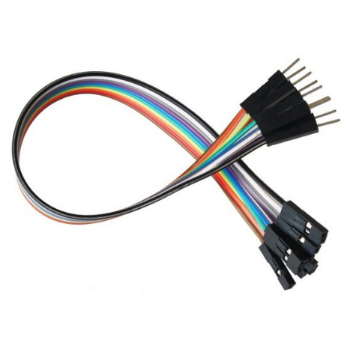

Figure 18: Jumper Wire

#### 3.1.2.5 Switch:

The Power Switch Is A Rocker Switch and It Has Two Symbols on the Face: “O” And “—“. They Are The International Symbols For Power “On” And Power “Off”. This Is Useful Thing for Our Project Will Help Us to Stop Our System and it show in figure 19.

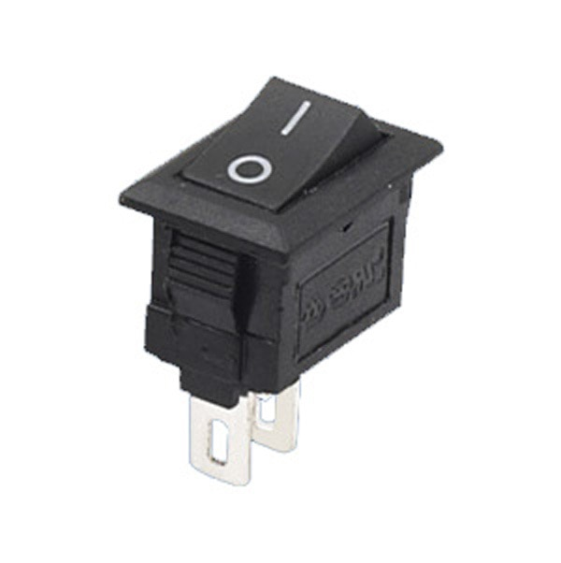

Figure 19: Switch

#### 3.1.2.5 Thermal Sensor:

It is a device which detects temperature. This sensor is used to make difference between human and other object and it sends the information about object to Arduino and it show in figure 20.

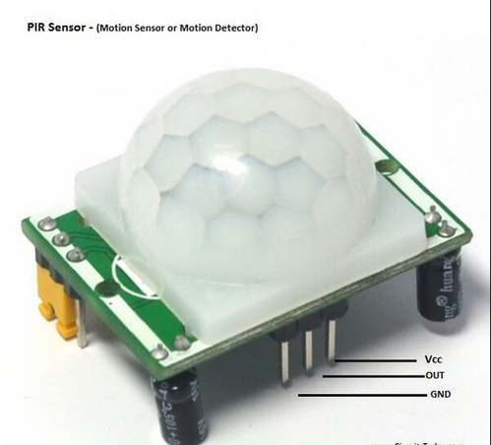

Figure 20: Thermal Sensor

### 3.1.3 System Constraints

Arduino board once programed it becomes unchangeable. That’s why we use Proteus IDE software for simulation first of all we assemble components of robot with each other’s in Proteus IDE and then check the connectivity of component in Proteus IDE and then write the program for robot and install the program into that robot chip and run that program at Proteus IDE after complication these process and clear about the program correctness than installed the program at real smart Robot.

### 3.1.4 External Interface Requirements

The UODSRS is required four type of External interface requirements which are hardware interface, Software interface, User interface and Communication, These all interfaces are discuss in detail below.

### 3.1.4.1 User Interface requirements:

UODSRS has two types of software. The first one hasn’t UI this is for robot and the second one is bulleted software has UI which is available in every mobile that is SMS application through this application the user and robot communicate with each other. The UI is easy to operate, Easy to Understand, Does not required additional training and quick in response.

### 3.1.4.2 Hardware Interface Requirements:

The UODSRS have following hardware requirements which are given below.

1. Arduino Mega
2. Ultrasonic Sensor
3. Temperature Sensor
4. Length Sensor
5. Motor
6. Node MCU
7. Jumper Wires
8. NodeMCU
9. Device (any android device)

3.1.4.2.1 Arduino Mega 2560

The Arduino Mega 2560 is a microcontroller board based on the ATmega2560 (datasheet). It has 54 digital input/output pins (of which 14 can be used as PWM outputs), 16 analog inputs, 4 UARTs (hardware serial ports), a 16 MHz crystal oscillator, a USB connection, a power jack, an ICSP header, and a reset button.

3.1.4.2.2 Ultrasonic Sensor

As the name indicates, ultrasonic sensors measure distance by using ultrasonic waves. The sensor head emits an ultrasonic wave and receives the wave reflected back from the target. Ultrasonic Sensors measure the distance to the target by measuring the time between the emission and reception.

3.1.4.2.3 NodeMCU

What is NodeMCU? The NodeMCU (Node Microcontroller Unit) is open source software and hardware development environment that is built around a very inexpensive System-on-a-Chip (SoC) called the ESP8266

3.1.4.2.4 Jumper Wire

A jump wire is an electrical wire, or group of them in a cable, with a connector or pin at each end, which is normally used to interconnect the components of a breadboard or other prototype or test circuit, internally or with other equipment or components, without soldering.

3.1.4.2.5 PIR Sensor

PIR sensors are more complicated than many of the other sensors explained in these tutorials (like photocells, FSRs and tilt switches) because there are multiple variables that affect the sensors input and output. To begin explaining how a basic sensor works, we'll use this rather nice diagram

The PIR sensor itself has two slots in it; each slot is made of a special material that is sensitive to IR. The lens used here is not really doing much and so we see that the two slots can 'see' out past some distance (basically the sensitivity of the sensor). When the sensor is idle, both slots detect the same amount of IR, the ambient amount radiated from the room or walls or outdoors. When a warm body like a human or animal passes by, it first intercepts one half of the PIR sensor, which causes apositive differential change between the two halves. When the warm body leaves the sensing area, the reverse happens, whereby the sensor generates a negative differential change. These change pulses are what is detected.

### 3.1.4.3 Communication Interface Requirements:

This is the major interface requirement in our project. It is used for Communication between robot and user for this they need a network signal to do communication with each other.

### 3.1.4.4 Software Interface Requirements:

The UODSRS have required any operating software of the following for complete the communication between robot and user.

1. Any computer operating software (Window’s, Linux and UNIX etc.).
2. mobile application

## 3.2 Functional Requirements

The technical work of UODSRS is to read route and detect object and evaluate the object between living-thing and nonliving- thing and measure the length between robot and obstacle after that it choose the shortest route between starting point to obstacle and send that all information to user through NodeMCU communication module (Security officer) about obstacle and reach shortest route to obstacle.

### 3.2.1 Use Cases

A requirement model for requirements analysis is mainly completed by use cases and the use case model also controls other parts of the system development. In the use case model, actors represent what will interact with the system and those need to communicate with the system. Use case model refers to what the system will perform after communication with both actors and other use cases and the diagram of UODSRS is show in figure 21.

The first use case of our proposed smart system is input data and the actor is UODSRS. Our smart robotic system get input from ultrasonic sensor and PIR sensor and the UODSRS detect the object through this sensor and make real time decision through these data and the second use case is Evaluate object. In this use case PIR sensor sent data to arduino mega 2560 and the arduino mega 2560 evaluate the object if object is living thing than UODSRS neglect that if object is non-living thing than send alert through NodeMCU which is show in Android application as well as on website and our third use case is measure length and shortest path detection for this we use ultrasonic sensor it measure the distance from UODSRS to that object or obstacle. Our fourth use case is sending alert. Our smart system is make real time communication with the disaster management group about the environment where it is presents.

Route Read

Detect Object

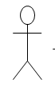

Calculate Length



Send Massage

USER

Receive Massage

UODSRS

Measure Temperature

Figure 21: Diagram of Use Case

|  |  |  |  |  |
| --- | --- | --- | --- | --- |
| UC-01: Input | | | | |
| Use Case Id: | | UC-01 | | |
| Actors: UODSRS | | | | |
| Feature: UODSRS Read Route | | | | |
| Pre-Condition: | | Ultrasonic Sensor  Arduino Micro-Controller | | |
| Scenarios | | | | |
| Step# | Action | | | Software Reaction |
| 1. | When We On The Power Button Of Robot. | | | 2. Arduino Board Starts Working. |
| 3. |  | | | 4. The Component Get Instruction From Arduino Board |
| 5. |  | | |  |
| 6. |  | | | 7. The Robot Start Read Route |
| Step# | Description | | | |
|  | Upon Completion Of This Use Case, The Robot Move Forward | | | |
| Use Case Cross Referenced | | | Evaluate Object | |

Table 2: UC-1

The first use case of our proposed smart system is input data and the actor is UODSRS. Our smart robotic system get input from ultrasonic sensor and PIR sensor and the UODSRS detect the object through this sensor and make real time decision through these data. Upon Completion of This Use Case, The Robot Move Forward after that it referenced to object evaluation use case.

|  |  |  |  |  |
| --- | --- | --- | --- | --- |
| UC-02: Evaluate Object | | | | |
| Use Case Id: | | UC-02 | | |
| Actors: UODSRS | | | | |
| Feature: Evaluate Object | | | | |
| Pre-Condition: | | Thermal Sensor and Arduino Micro-Controller  Object must be present | | |
| Scenarios | | | | |
| Step# | Action | | | Software Reaction |
| 1. | The Robot Detect The Object | | | 2. check the temperature of object |
| 3. |  | | | 4. send condition result to Arduino Micro-controller |
| Post Conditions | | | | |
| Step# | Description | | | |
|  | Upon Completion Of This Use Case, robot measures the distance and gets the shortest Route between starting point to that object. | | | |
| Use Case Cross Referenced | | | Check length and shortest Route | |

Table 3: UC-2

The second use case is Evaluate object. In this use case PIR sensor sent data to arduino mega 2560 and the arduino mega 2560 evaluate the object if object is living thing than UODSRS neglect that if object is non-living thing than send alert through NodeMCU which is show in Android application as well as on website. Upon Completion of This Use Case, robot measures the distance and gets the shortest Route between starting point to that object.

|  |  |  |  |  |
| --- | --- | --- | --- | --- |
| UC-03: Measure Length and shortest Route | | | | |
| Use Case Id: | | UC-03 | | |
| Actors: UODSRS | | | | |
| Feature: Measure Length and shortest Route | | | | |
| Pre-Condition: | | Length Sensor and Arduino Micro-Controller  Object must be present | | |
| Scenarios | | | | |
| Step# | Action | | | Software Reaction |
| 1. | The Robot Evaluate The Object | | | 2. Measure distance between object and robot. |
| 3. |  | | | 4. Set shortest Route between starting point to object. |
| Post Conditions | | | | |
| Step# | Description | | | |
|  | Upon Completion Of This Use Case, the robot send these all data to user | | | |
| Use Case Cross Referenced | | | Send Alert | |

Table 4: UC-3

In this use case is measure length and shortest path detection for this we use ultrasonic sensor it measure the distance from UODSRS to that object or obstacle. The Robot Evaluate the Object, Measure distance between object and robot. Set shortest Route between starting point to object. Upon Completion of This Use Case, the robot sends these all data to user

|  |  |  |  |  |
| --- | --- | --- | --- | --- |
| UC-04: Send Alert | | | | |
| Use Case Id: | | UC-04 | | |
| Actors: UODSRS | | | | |
| Feature: Send Alert | | | | |
| Pre-Condition: | | NodeMCU and Arduino Micro-Controller  Network must available | | |
| Scenarios | | | | |
| Step# | Action | | | Software Reaction |
| 1. | The Robot measure distance and shortest route | | | 2. Check IP |
| 3. |  | | | 4. Send information through IP Address |
| Post Conditions | | | | |
| Step# | Description | | | |
|  | Upon Completion Of This Use Case, the Security officer receive alert. | | | |
| Use Case Cross Referenced | | | Receive Alert | |

Table 5: UC-4

In this use case is sending alert. Our smart system is make real time communication with the disaster management group about the environment where it is presents. The Robot measure distance and shortest route and it Check IP address if IP address is available then it data through IP Address which is show is user mobile application and as well as on website it show. Upon Completion of This Use Case, the disaster management group receive alert.

### 3.2.1.1 Application USE Case

**Autonomous**

**Manual**

**Forward**

**Backward**

**Left**

**Right**

**Stop**

**Alert**

### 3.2.2 flow Chart Diagram

User

Disaster Management Group

Figure 22: Diagram of Application Use Case

In application there are eight use case but one of them Alert is for disaster management group and other seven is for UODSRS operator. There are three main use cases the first one important use cases is manual when the UODSRS operator press the manual button then the smart system UODSRS in manual mode. In these mode the UODSRS get instruction from application user e.g. if user press forward button then UODSRS move forward and if he press backward button then it move backward and if he press left button then it will move in left direction and if he press right button than it will turn right and if he press stop button then the smart system UODSRS will stop.

If the application user presses the autonomous button then the smart system UODSRS will in automatic mode in this mode the UODSRS will make real time discussion to move forward, backward, left, right and stop. It gets data from ultrasonic sensor to make real time discussion and it also make real time communication to disaster management group through NodeMCU and it show in application and as well as in website. The GUI of application is show in figure 22.1.

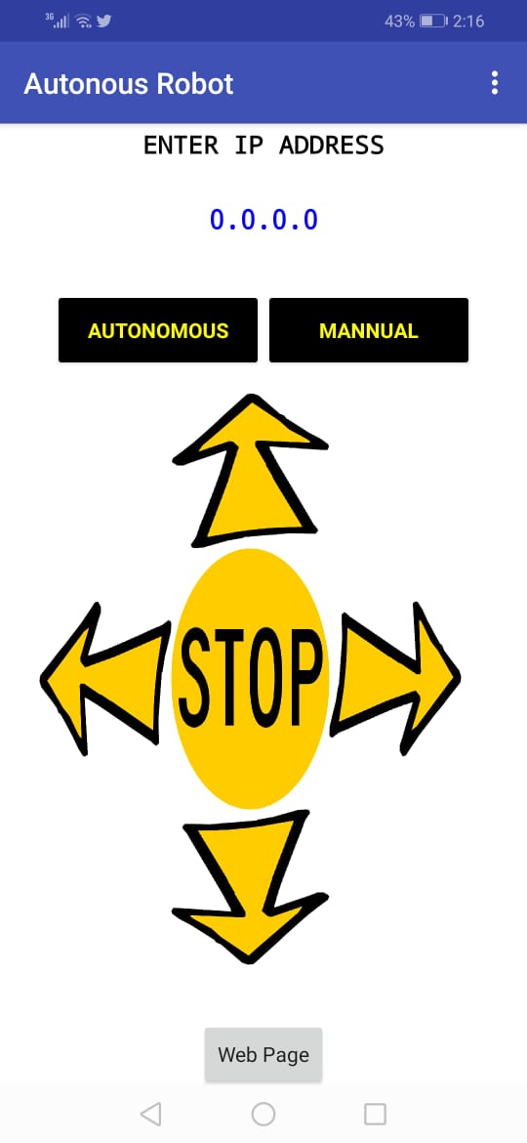

Figure 22.1: Diagram of Application



Figure 23: Flow Chart Diagram of UODSRS

In above figure 22 you see the mechanism of our System UODSRS. First of all the user should power on the UODSRS and the system its self-searching the path and move in forward direction if it detect any object or obstacle in its path then it stop and send various alert to user and it check the path in right if there is path than it turn right if there is no path available in its right then its check its left if there is path than it turn left if there is no path available in its left then it take 180 degree turn and move forward and do surveillance in the environment.

### 3.2.3 Sequence Diagram:

Figure 24: Sequence diagram of UODSRS

The smart system UODSRS capture the environment information and find the path if it detecting any obstacles its check it right side if there is path than it turn right. If right side is block then it checks its left side if there is path to move then it takes left turn. If left side is block to it take 180 degree turn and check the environment and search the obstacle. If it detect the obstacle than it stop for 5ms and measure the distance between itself and that obstacle and send alert to disaster management group and the disaster management group take an action to remove the obstacle.

## 3.3 Non-functional Requirements

Non-functional requirements of UODSRS are divided into two categories that are hardware and software non-functional requirements.

Hardware Non-functional Requirements are following below.

### 3.3.1 Battery should be charge

The battery is playing main role in UODSRS. The devices are work through battery and there are two things in battery voltage and empire and the speed depend on these and one more thing is important for speed of UODSRS that is charge level of battery.

### 3.3.2 Maintain the robot

Maintenance mean to check the every component of smart system UODSRS. The components like NodeMCU connectivity with arduino and with Mobile application and checking the battery charge and checking all wire connectivity and checking the all sensor which attach to the arduino mega 2560.

### 3.3.3 User should have mobile

User should have must smart mobile (Android) to communicate with the smart system UODSRS and NodeMCU must connected with arduino mega 2560 and the network must be available at that environment where the smart system is surveillance.

### 3.3.4 Check memory backup

The send data alert to smart mobile (Android) through server but for safety we store the alert in memory card which is attached with arduino mega 2560.

### 3.3.5 Safe Arduino Micro-controller from water

Arduino mage 2560 is must be away from water and the area where water quantity is more than 2 feet the system is away from those areas.

### 3.3.6 Network Signal

The communication done with help of network signal and the same network must be connecting with NodeMCU and mobile. NodeMCU generate an IP address and that IP address called in mobile application and through mobile application the smart system UODSRS is controlled.

## 3.4 Summary

For the development of UODSRS we use agile methodology because it is easy to find error and easy to implement new thing in project. The hardware we use for development of UODSRS are Arduino Micro-controller, ultrasonic sensor, thermal sensor, jumper wire, switch, battery and NodeMCU and the software we us for the development for UODSRS are Arduino software IDE and Proteus IDE and the use case of UODSRS are detect object, evaluate object, length measure, send alert and receive alert and send alert to user via android app. The communication done with help of network signal and the same network must be connecting with NodeMCU and mobile. NodeMCU generate an IP address and that IP address called in mobile application and through mobile application the smart system UODSRS is controlled.

The smart system UODSRS capture the environment information and find the path if it detecting any obstacles its check it right side if there is path than it turn right. If right side is block then it checks its left side if there is path to move then it takes left turn. If left side is block to it take 180 degree turn and check the environment and search the obstacle. If it detect the obstacle than it stop for 5ms and measure the distance between itself and that obstacle and send alert to disaster management group and the disaster management group take an action to remove the obstacle.

UODSRS has two types of software. The first one hasn’t UI this is for robot and the second one is bulleted software has UI which is available in every mobile that is UODSRS application through this application the user and robot communicate with each other. The UI is easy to operate, Easy to Understand, Does not required additional training and quick in response.

The technical work of UODSRS is to read route and detect object and evaluate the object between living-thing and nonliving- thing and measure the length between robot and obstacle after that it choose the shortest route between starting point to obstacle and send that all information to user through NodeMCU communication module (Security officer) about obstacle and reach shortest route to obstacle.

# CHAPTER 4

# SYSTEM IMPLEMENTATION

In this chapter we present the Implementation of our project.

4.1 SYSTEM DEVELOPMENT PROCESS

Our system UODSRS divided into several iterations. In every iterations there is a new function implemented on a system. The Iterations are listed below:

1. Object detection
2. Object evaluation
3. Manual controlling
4. Autonomous system
5. Sending alert using IoT
6. Communication between nodeMCU and Arduino

Object detection:

Our system UODSRS is capable to detect objects via Ultrasonic sensors and makes real time communication between Arduino mega and nodeMCU and also makes real time decisions.

Object evaluation:

In our system UODSRS, the PIR sensor is responsible to evaluate object. PIR sensor detects any movement and evaluate either the object is living thing or not.

Manual controlling:

We can also control our system UODSRS through android app which is connected to our system via nodeMCU (IoT).

Autonomous system:

Our system UODSRS is capable to move automatically and makes decisions by its own and evaluate route of patrolling.

Sending alert using IoT:

Our system is capable to send alerts on app whenever any obstacle comes in its way. The nodeMCU is responsible to make communication between Arduino and android app.

Communication between nodeMCU and Arduino:

The nodeMCU and Arduino are exchanging information with each other through software serial.

4.2 Simulation Model

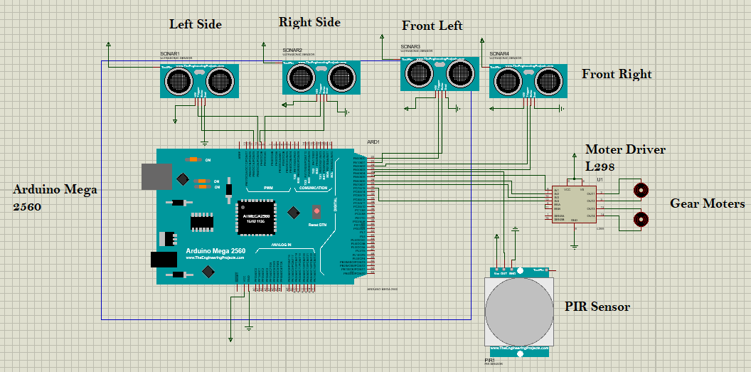Figure 25: Simulation Result

The above simulation result we use Proteus IDE and the drivers we use are arduino mega with ultrasonic sensor, PIR sensor, Motor Driver L298 and Gear Motor.

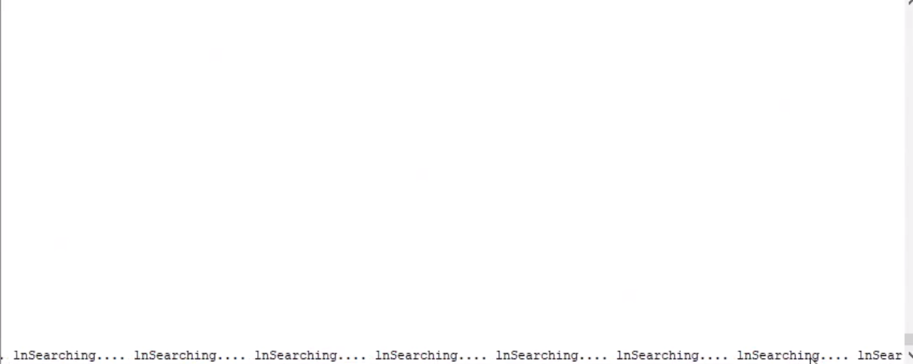

Figure 26: Simulation Result

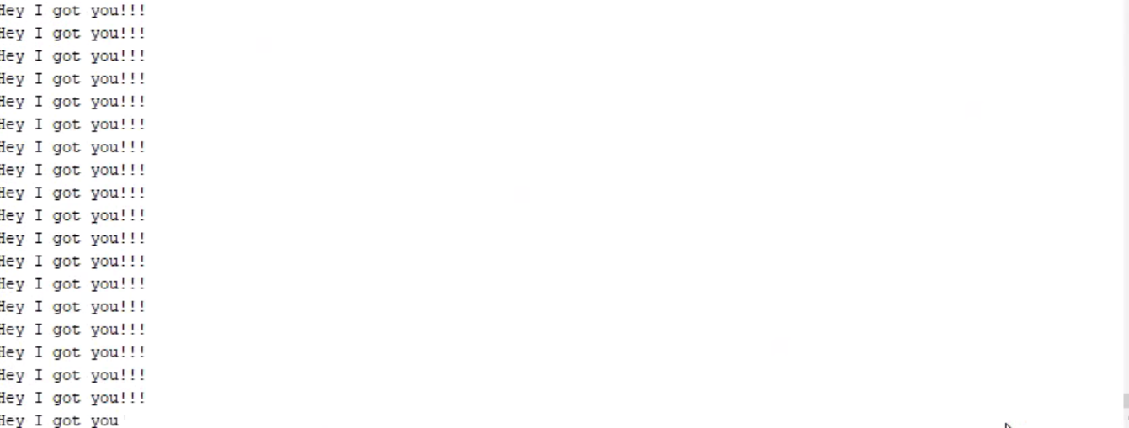

Figure 27: Simulation Result

In above figure 23,24 & 25 you see the result of simulation in figure 23 you see the connectivity of different component of the system UODSRS and in figure 24 & 25 you see the result of the system UODSRS.

4.3 GUI DESIGN

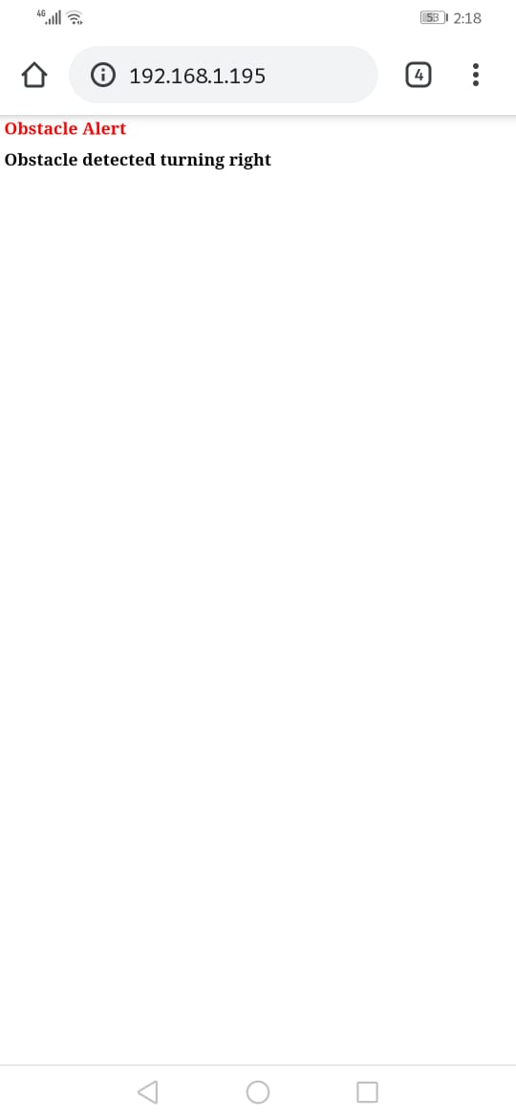

Figure 28: Application & websites for System UODSRS

When the UODSRS operator presses the manual button then the smart system UODSRS is in manual mode. In these mode the UODSRS get instruction from application user e.g. if user press forward button then UODSRS move forward and if he press backward button then it move backward and if he press left button then it will move in left direction and if he press right button than it will turn right and if he press stop button then the smart system UODSRS will stop. If the application user presses the autonomous button then the smart system UODSRS will in automatic mode in this mode the UODSRS will make real time discussion to move forward, backward, left, right and stop. It gets data from ultrasonic sensor to make real time discussion and it also make real time communication to disaster management group through NodeMCU and it show in application and as well as in website.

4.4 SUMMARY

In this chapter we discussed about system development process in which we clarify object detection, object evaluation, manual controlling, autonomous system, IoT and communication between nodeMCU and Arduino. Our system UODSRS divided into several iterations. In every iterations there is a new function implemented on a system. The Iterations are listed below:

1. Object detection
2. Object evaluation
3. Manual controlling
4. Autonomous system
5. Sending alert using IoT
6. Communication between nodeMCU and Arduino

When the UODSRS operator presses the manual button then the smart system UODSRS is in manual mode. In these mode the UODSRS get instruction from application user e.g. if user press forward button then UODSRS move forward and if he press backward button then it move backward and if he press left button then it will move in left direction and if he press right button than it will turn right and if he press stop button then the smart system UODSRS will stop. If the application user presses the autonomous button then the smart system UODSRS will in automatic mode in this mode the UODSRS will make real time discussion to move forward, backward, left, right and stop. It gets data from ultrasonic sensor to make real time discussion and it also make real time communication to disaster management group through NodeMCU and it show in application and as well as in website.

# CHAPTER 5

# RESULT AND DISCUSSION

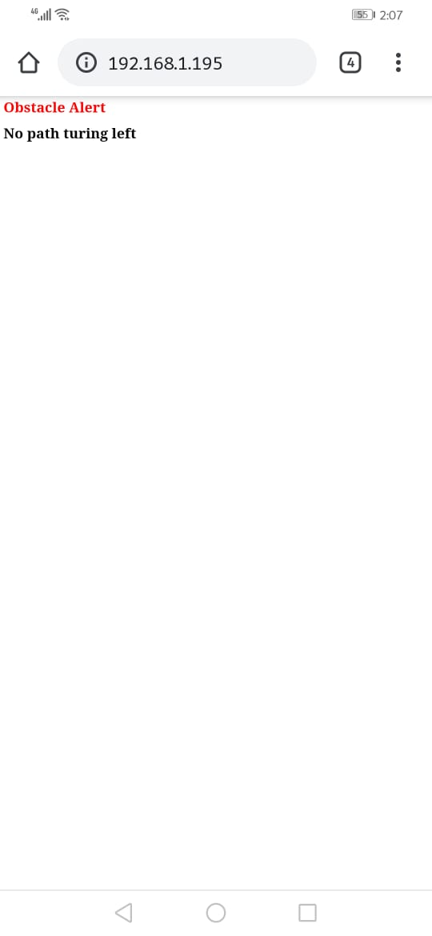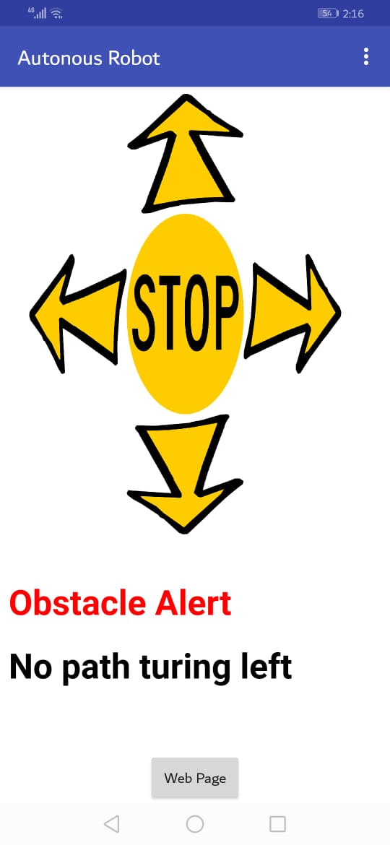

Figure 29: Application & websites for System UODSRS

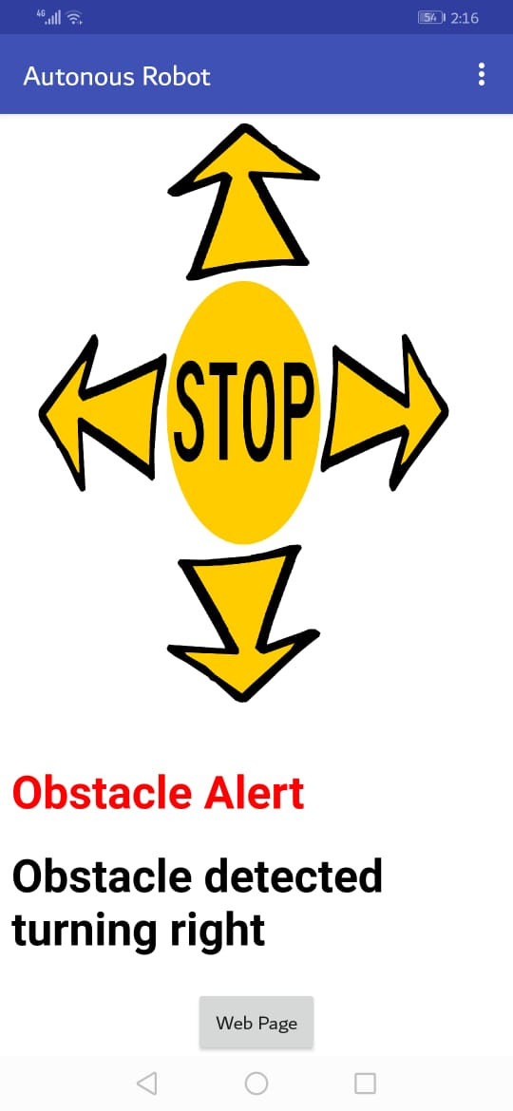

Figure 30: Application & websites for System UODSRS

In the above figure 29 & 30 you see the result of Application and website for the system UODSRS in these figure you see two button in top of the application the one button is for Autonomous and the another one is for Manual. If you press autonomous button then the system moving by itself and get real time decisions and sent various alert on application and website and if you press the manual bottom then one person is need to give command to system to move. Fro give command to system we see there are five buttons every button has different functionality the button are for Forward, Backward, left turn, right turn and Stop.

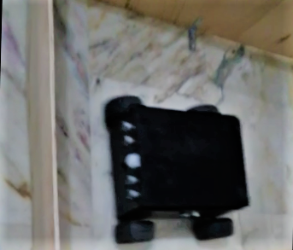

Figure 31.0: UODSRS moving forward

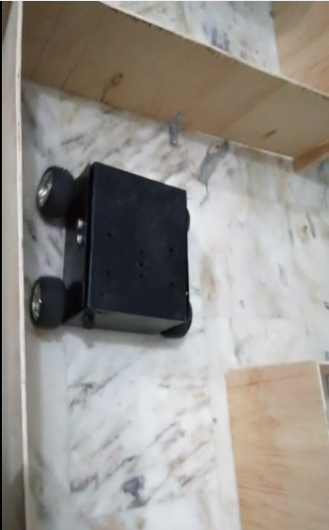

Figure 31.1: UODSRS Left turn

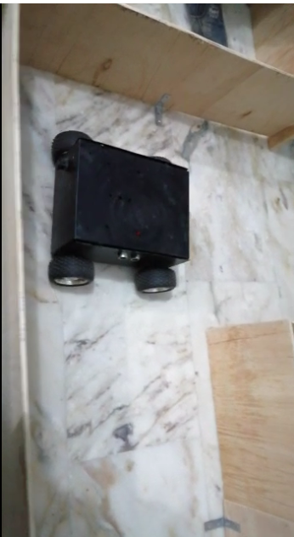

Figure 31.2: UODSRS take left Turn Again

In figure 30.0 our smart system UODSRS is detecting an obstacle in the front, right and left side. Our smart system UODSRS move right two times to form 180 degree turn in figure 31.1 and figure 31.2, moving forward to discover a new available path.

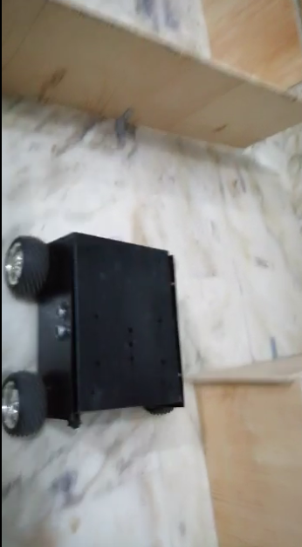

Figure 32.0: UODSRS System

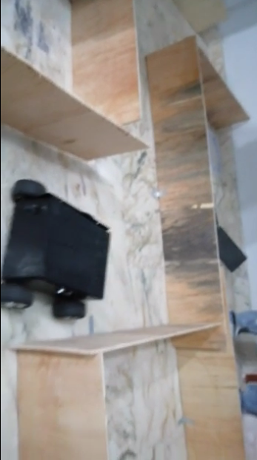

Figure 32.1: UODSRS Left Turn

In figure 32.0, 32.1 our smart system UODSRS is detecting an obstacle in the front and right, detecting obstacle, sending alert to the disaster management depart and going left after it. Our system UODSRS is then moving forward to discover a new available path.

# CHAPTER 6

# CONCLUSION AND FUTURE DIRECTIONS

In this chapter we present the conclusion and future work of UODSRS.

## 6.1 Conclusion

An our autonomous robot is a smart system that is now capable of moving on upper and under surface of the earth and it observe the environment and the UODSRS read the path when any obstacle is come in its path then it detect that obstacle and change the available path with respect to environment.

## 6.2 Future Directions

An autonomous robot is a smart system that is capable of moving on different upper and under surface unstructured environment. An autonomous robot is equipped with software intelligence to sense environment, detect obstacles in its route and move around an environment overcoming the obstacles.When this robot will detect any obstacles, it will send alert about obstacles and change its direction to the new available route means it will not go to where it came from it will be capable to choose a new route. We will control all of these motors by Arduino board. The moment of robot will be control by per-code program. We will receive alerts of our robot via android app which is Node MCU is playing a role of bridge between Arduino and android app. In future we use camera for live streaming.We use some more additional and latest sensors to detect the gases under surface of the earth and send various alerts to user about the gases which exits undersurface of the earth or use camera to live monitor any environment and In future we work on following areas which are following below.

1. Autonomous Car
2. Aero plan parking car
3. Detect Under water movements

# REFRENCES

[1]2019.[Online].Available: https://www.academia.edu/35334413/Obstacle\_Avoiding\_Smartcar\_using\_Arduino\_and\_Ultrasonic\_Sensors\_J-Component\_Report. [Accessed: 09- Jul- 2019].

[2] Tarshizi, E., Buche, M., Inti, B. and Chappidi, R. (2018). Text mining analysis of U.S. Department of Labor's MSHA fatal accident reports for coal mining. Mining Engineering, 70(4), pp.43-48.

[3] Obstacle Detection and Avoidance Methods for Autonomous Mobile Robot. (2016). International Journal of Science and Research (IJSR), 5(1), pp.1245-1249.

[4] https://www.ijltet.org/journal/151728819812%202051.pdf. (2018). International Journal of Latest Trends in Engineering and Technology, 9(3).

[5] http://www.ijarse.com/images/fullpdf/1491913433\_P634-638.pdf [Accessed 20 Mar. 2019].

[6]Pdfs.semanticscholar.org,2019.[Online].Available: https://pdfs.semanticscholar.org/2636/458e8c87f98a7b8aa1a9d0da5091551845a1.pdf. [Accessed: 09- Jul- 2019].

[7]"Project Report On obstacle avoiding robot | Robot | Technology", Scribd,2019.[Online].Available: https://www.scribd.com/document/295217556/Project-Report-On-obstacle-avoiding-robot. [Accessed: 09- Jul- 2019].

[8]"Project 1: 2WD Obstacle Avoiding Robot", Arduino Project Hub, 2019. [Online].Available:https://create.arduino.cc/projecthub/hda-robotics/project-1-2wd-obstacle-avoiding-robot-390ef8. [Accessed: 09- Jul- 2019].

[9]Ijarse.com,2019.[Online].Available: https://www.ijarse.com/images/fullpdf/1491913433\_P634-638.pdf. [Accessed: 09- Jul- 2019].

[10]Theseus.fi,2019.[Online].Available: https://www.theseus.fi/bitstream/handle/10024/71120/lok\_final\_thesis.pdf?sequence=1&isAllowed=y. [Accessed: 09- Jul- 2019].